EMSPlus Team

University of Maryland Global Campus

SWEN 670 Software Engineering Project

July 26, 2020

Earned Value Management Chart

This will be one of the many Earned Value Management updates that will keep track of our application project schedule, cost, and number of hours that’s being accounted for. Per the professor instructions, we’ve searched an hourly salary on the Indeed website for the position of Jr. Software Engineer:

##### “The estimated salary for a junior software engineer is $33.23 per hour in Baltimore, MD and $1,000 cash bonus per year” - <https://www.indeed.com/career/junior-software-engineer/salaries/Baltimore--MD?from=top_sb>

In addition, the professor as also establish that each member should work approximately 10 hours per week on the project. “You should spend around 10 hours per week on this project, from those 10 hours use the time that you are going to work on this project as that role to multiply with the rate, and then sum up the total amount to come up with the total project cost estimate” – Professor Mir Assadullah.

**EARNED VALUE**

The Earned value management will help the EMSPlus team to quantify the performance of a project. It compares costs and schedules to a baseline to determine if the project is on track.

|  |  |  |
| --- | --- | --- |
| EAC | ACWP | BCWP |
| $195,179.47 | $155,091.02 | $152,514.09 |

EARNED VALUE OVER TIME

The project’s earned value based on the status date. If actual cost (ACWP) is higher than earned value (BCWP), then the project is over budget. If planned value (BCWS) is higher than earned value, then the project is behind schedule.

VARIANCE OVER TIME

Cost and schedule variances for the project based on status date. If CV is negative then, the project is over budget. If SV is positive then the project is behind schedule.

INDICES OVER TIME

Cost and schedule performance indices for the project based on status date. The greater the performance index, the more on schedule and cost saving the project.

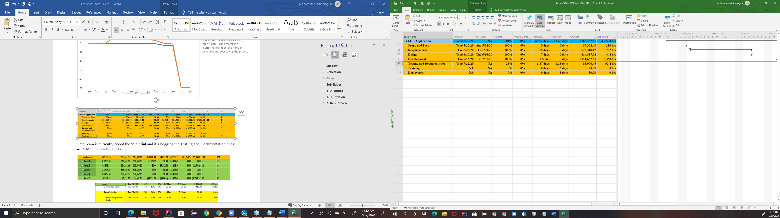

Our Team is currently ended the 5th Sprint and it’s begging the Testing and Documentation phase – EVM with Tracking data

